**CS 5551 Third Increment Report** Adam Carter

Class ID: 9, Project Group ID: 1

CS 5591 – Spring 2015

1. **Introduction**

This is the summary report of the third iteration of work performed on the Terrapin Collection Manager system. This system proposes to implement a framework for organizing and managing a user’s Board Game collection. The full background of this project can be found in the Project Proposal Document [1] submitted previously.

For this third iteration, my primary focus was on the administration side of the system. Now that content is being indexed, it needs to be organized, which means that searching capabilities needed to be provided for the content in question. Additionally, continuing from last iteration, about half the time spent during this iteration was on front-end client development, rendering and completing the workflow

Since many of the details behind the architecture of this system were discussed previously in my Project Plan [2], I will not be repeating elements of those discussions here except to discuss changes or additions. This involved a lot of learning on my part, as I am inexperienced with client-side development of web applications. My focus was on creating responsive pages using jQuery and Bootstrap with layouts that scale well for both rich client environments and mobile platforms.

1. **Objectives**

I had several main objectives with this iteration. First, I needed to improve the agent process to continue to make the review process more automated than manual. Second, I needed to implement the administration clients that would be capable of reviewing this content. Third, I wanted to implement the remaining basic CRUD operations through REST services to allow me to focus almost exclusively on UI and presentation in the fourth iteration.

Some time was lost during this iteration, both due to Spring Break, as well as personal illness, which limited the amount of time I was able to commit to this project in addition to the other demands on my time. That being said, I am please with what I was able to learn and accomplish during this iteration.

One of the key areas in which I had to do a lot of learning was responsive layout development. I spent a lot of time interacting with CSS, learning how to use bootstrap layouts effectively, and adding intelligent features from jQuery, like autocomplete fields. The time spent learning these skills now should improve development time in the final iteration, which contains a larger portion of UI work.

1. **Design Overview**

My architectural model remains largely intact from the initial planning. I have added new parameters to various service calls, and created one new service, but fundamentally, the architectural plan as initially designed has been well suited to the work being done at this point in the project.

Expanding on the HTML split page model from the second iteration, I created a separate sub-folder in my web project root to host the admin pages required for content review and approval. This allowed me greater freedom to experiment with CSS changes to my common .css file to judge how they impact layout. I also leveraged focused more on response times, using compression tools to reduce image size and trying to use simpler light-weight functions instead of more expensive feature-rich calls.

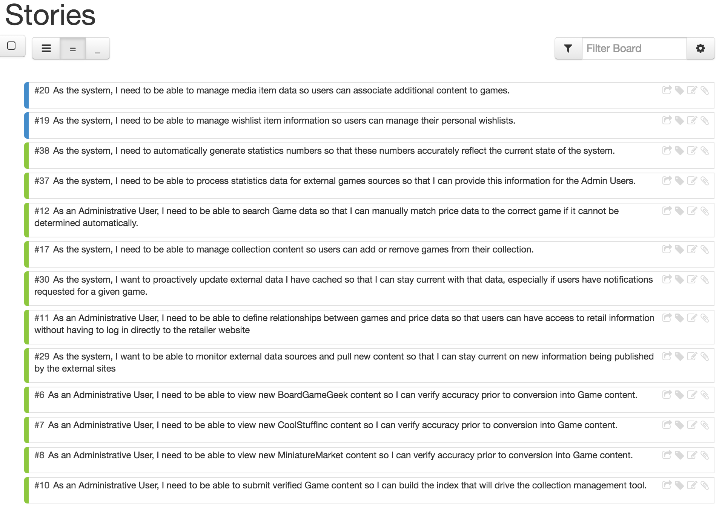

From a stories perspective, I was able to complete a decent number of stories this iteration, as well as leave fewer in flight heading into the final development iteration. I completed 11 stories with 2 others having been begun which will be transitioned into the fourth iteration. As can be seen, most of these stories have to do with the Administrative User role, which was fully realized this iteration.

There are now 10 stories that have been included in the fourth iteration, with another two items still in the backlog. Most of those items focus on the main collection user, and are front-end oriented stories, now that the spine of the system is in place. I expect to be able to deliver most if not all of the originally planned features by the end of this project.

1. **Implementation Details**

While last iteration I used TLOC (Total Lines of Code) and MLOC (Meaningful Lines of Code), I will not be presenting those statistics again. Progress has been made, but as I mentioned, a fair amount of time this iteration was dedicated to learning to work with Bootstrap and jQuery-UI, so in some ways progress was slower than writing familiar code.

Two new REST endpoints were implemented this release.

/auto

/stats

The /stats end-point was designed to provide a quick query for collection metrics. The /auto end-point was designed to provide access to a stripped down data set to be used to searching games via an auto-complete input field.

Both the GET and PUT operations for /external/bggdata, /external/csidata, /external/mmdata, and /game were significantly enhanced to support a variety of new search options and parameters, as well as cascading updates behind the scenes to support administrative user tasks. I’m some ways, these tasks were taken from the initial concept that was designed for use with the /search REST end-point, but made more sense to be refactored into the source REST end-point to avoid redundant code.

For reference, the code repositories for each project are listed below. All code for this release has been checked in to the Master branch of each project. Because class diagrams at this point are a little large to make inclusion in this document meaningful, they have been uploaded as part of the github project under the src/model folders.

* **ac-games-pojos** – <https://github.com/apshaiTerp/ac-games-pojos>
* **ac-games-db** – <https://github.com/apshaiTerp/ac-games-db>
* **ac-games-db-mongo** – <https://github.com/apshaiTerp/ac-games-db-mongo>
* **ac-games-restservice-spring** – <https://github.com/apshaiTerp/ac-games-restservice-spring>
* **ac-games-agent** – <https://github.com/apshaiTerp/ac-games-agent>
* **agent-site** – <https://github.com/apshaiTerp/agent-site>

As most of the other code changes are in support of the new front-end workflow, I will include some screen shots of the site in both Google Chrome and Mobile usage:

Presented in Order are:

The Main Statistics Page (which is the ‘home’ site for Admin users)

The Board Game Geek Review Page

The CoolStuffInc Review Page

The MiniatureMarket Review Page

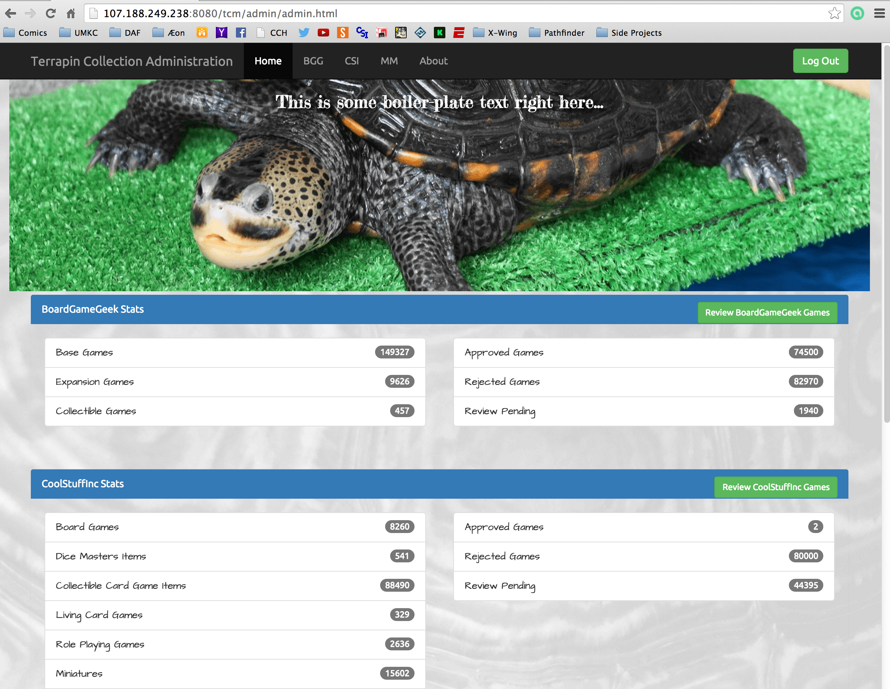

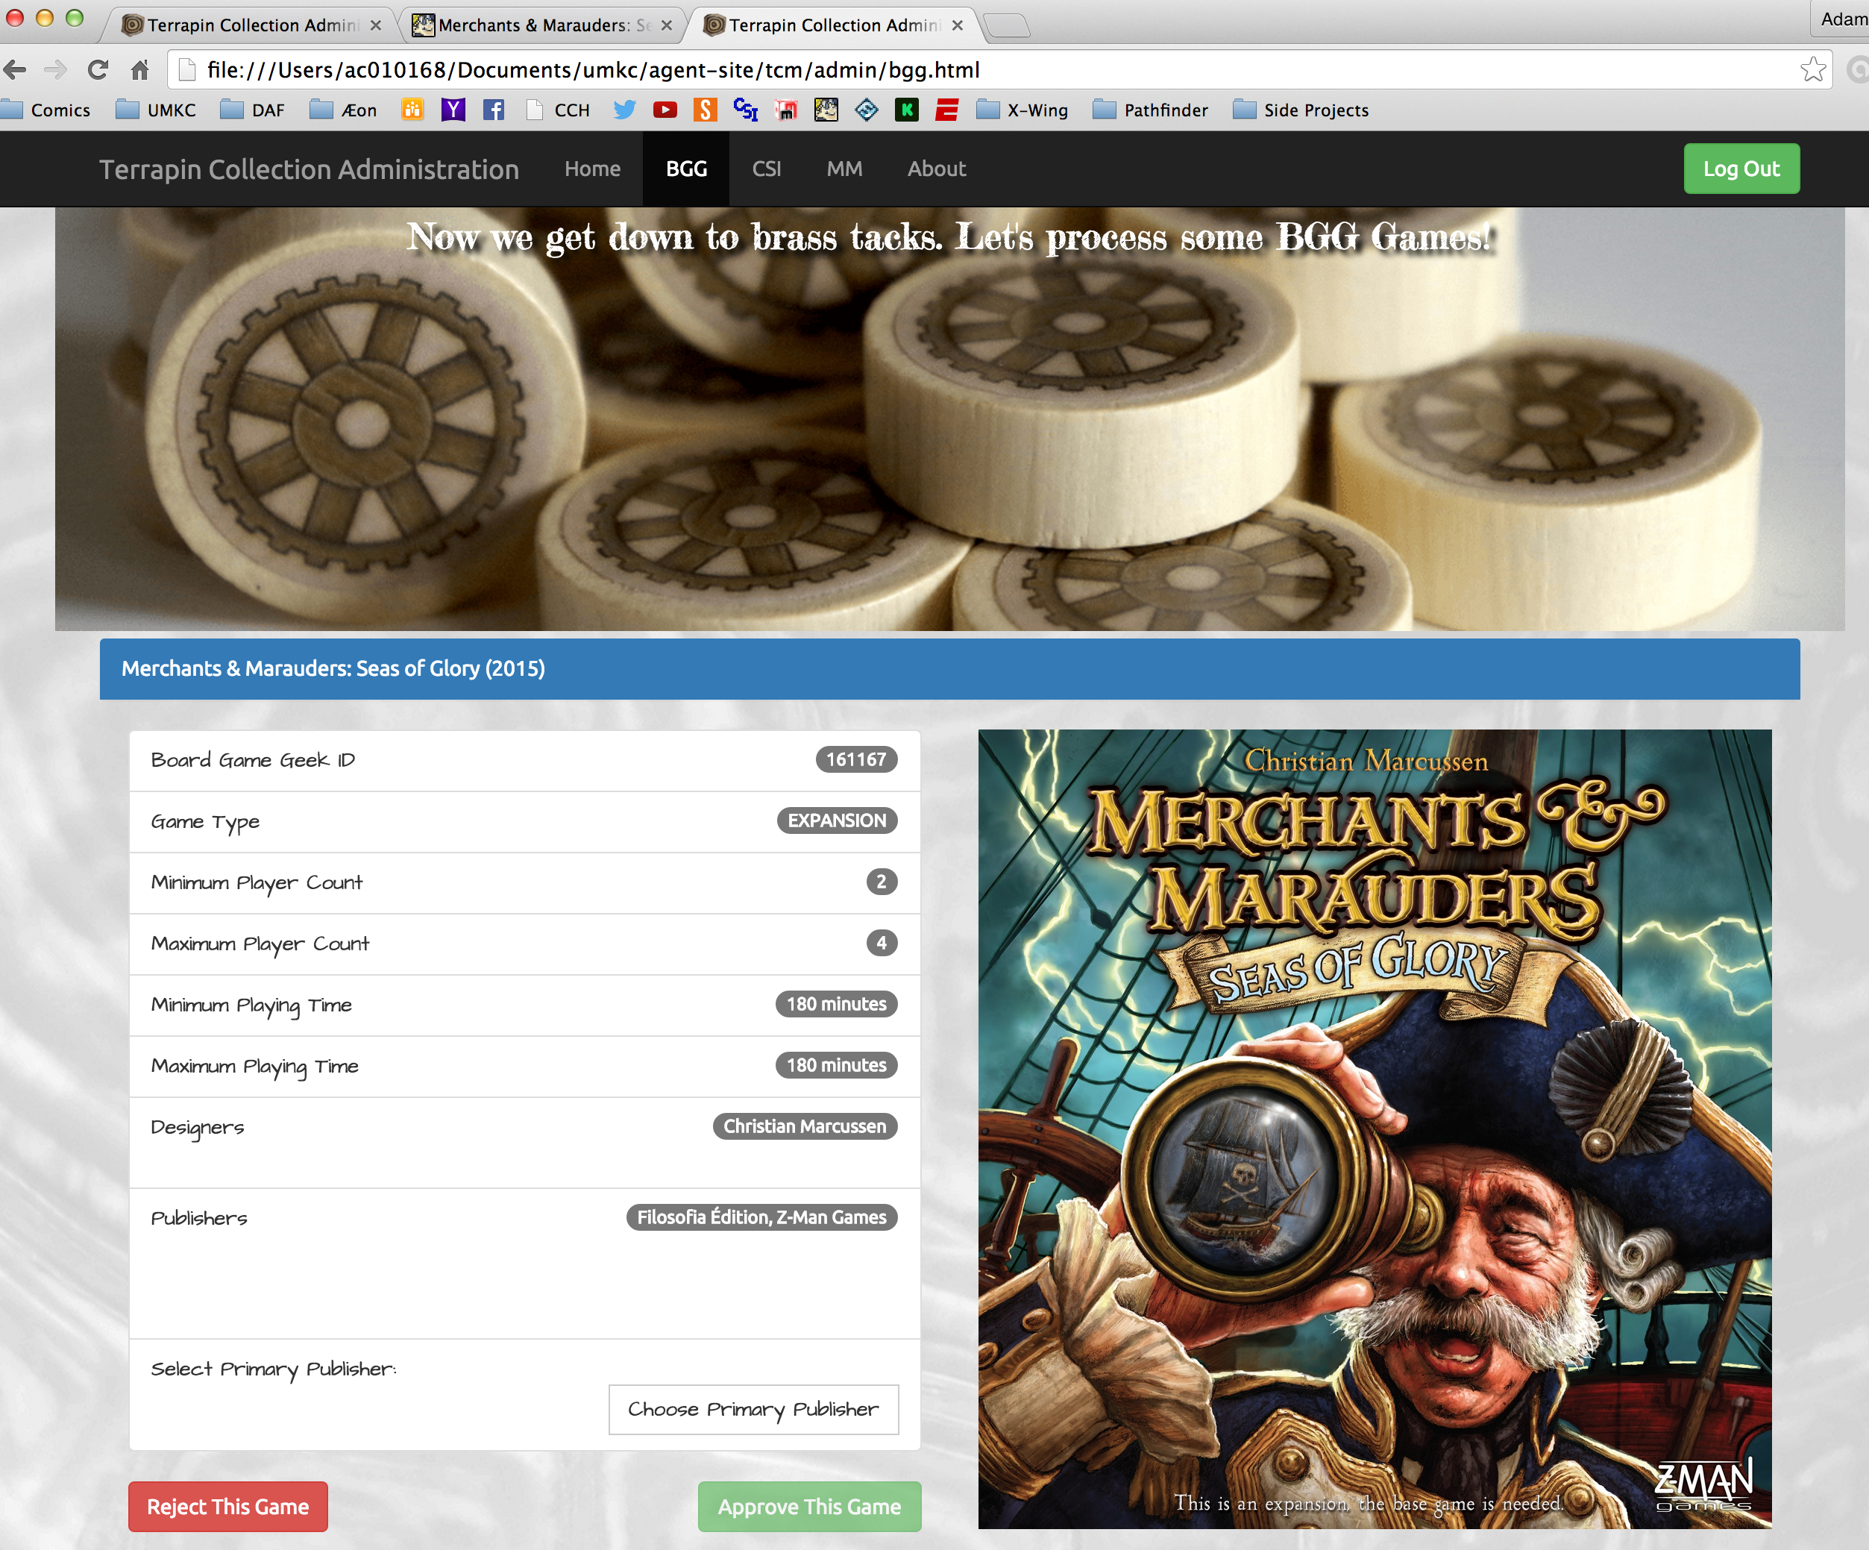

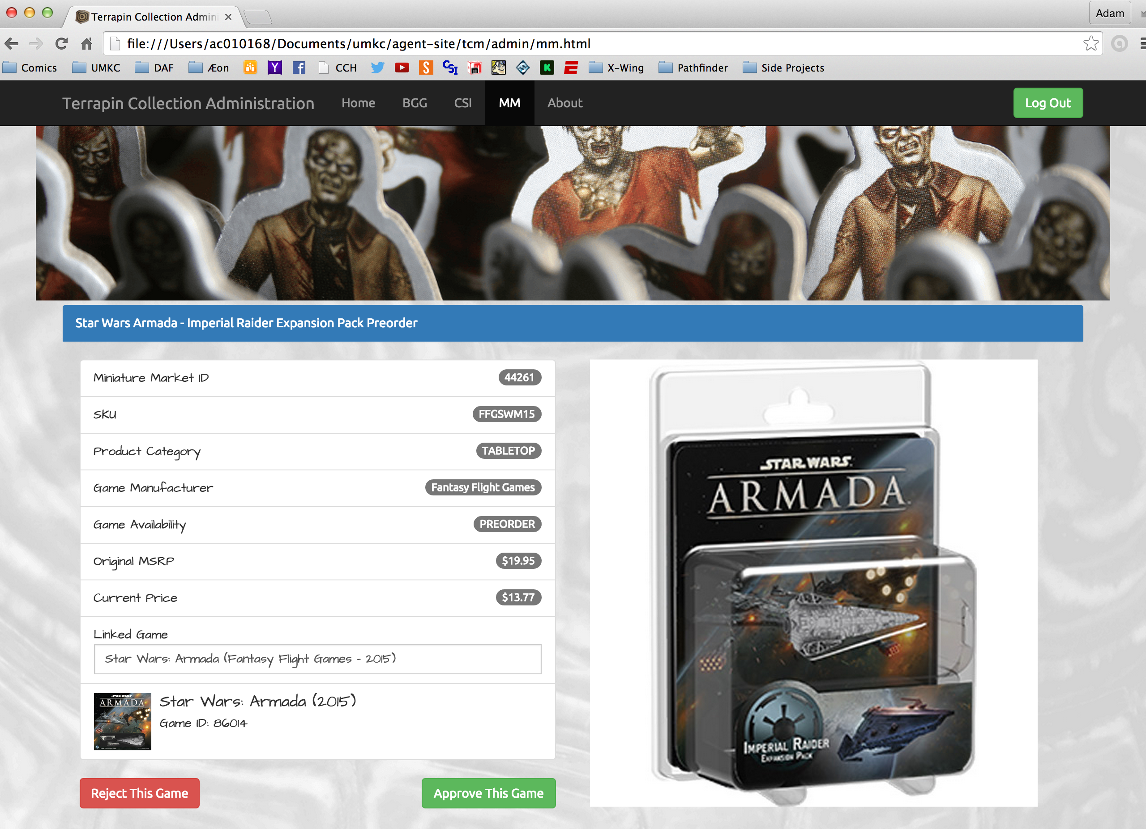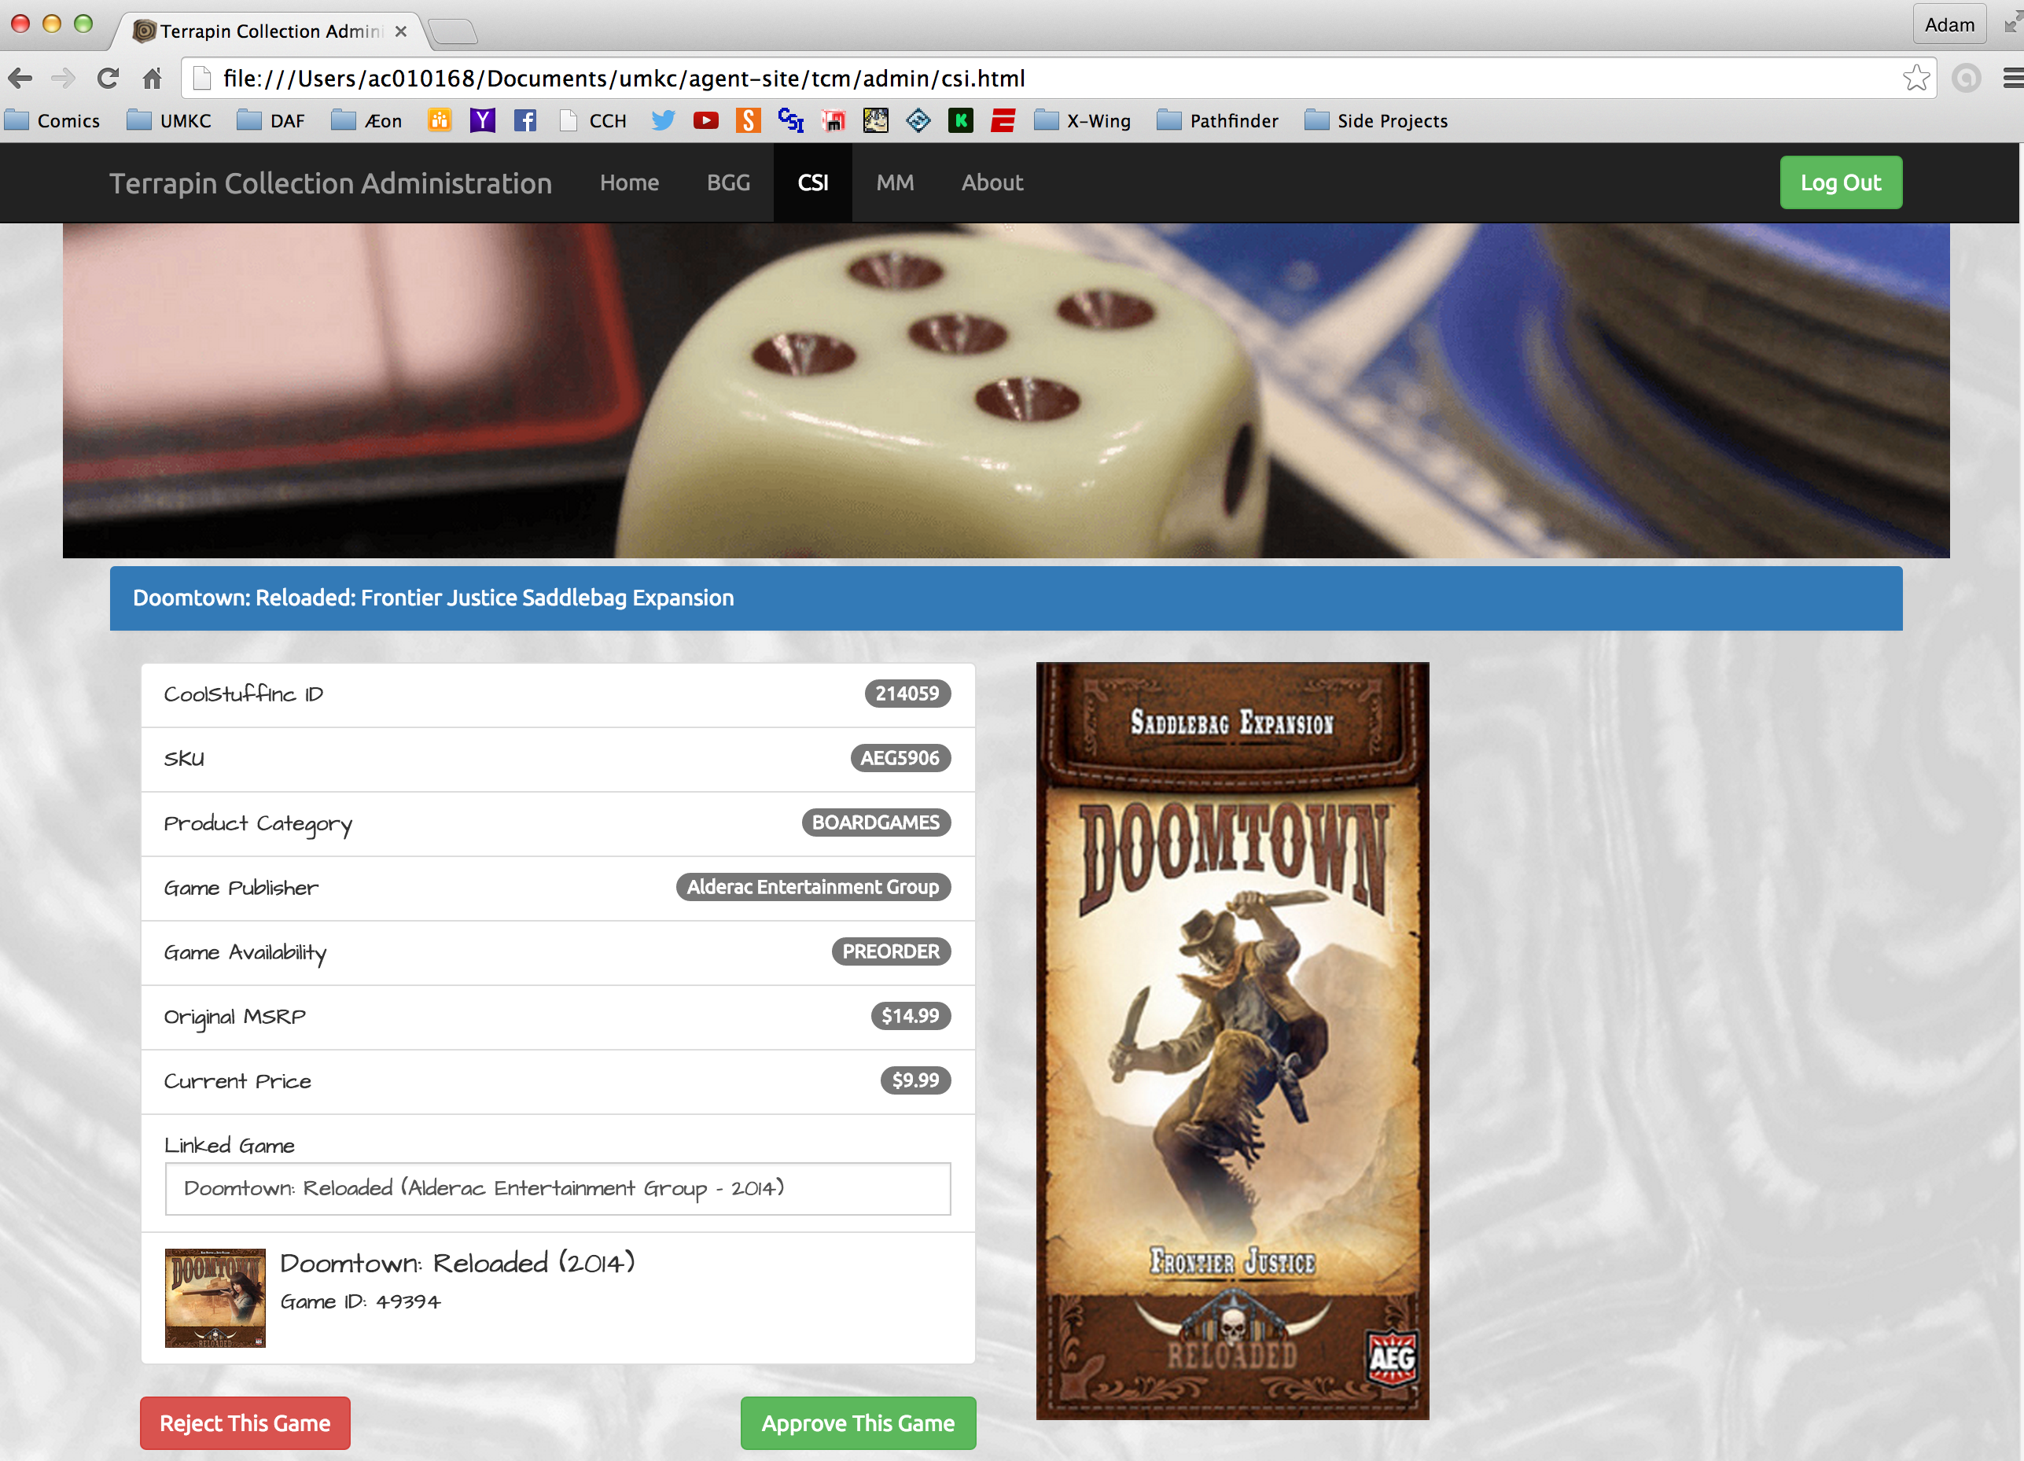

And now for some of the Mobile views of portions of the same page:

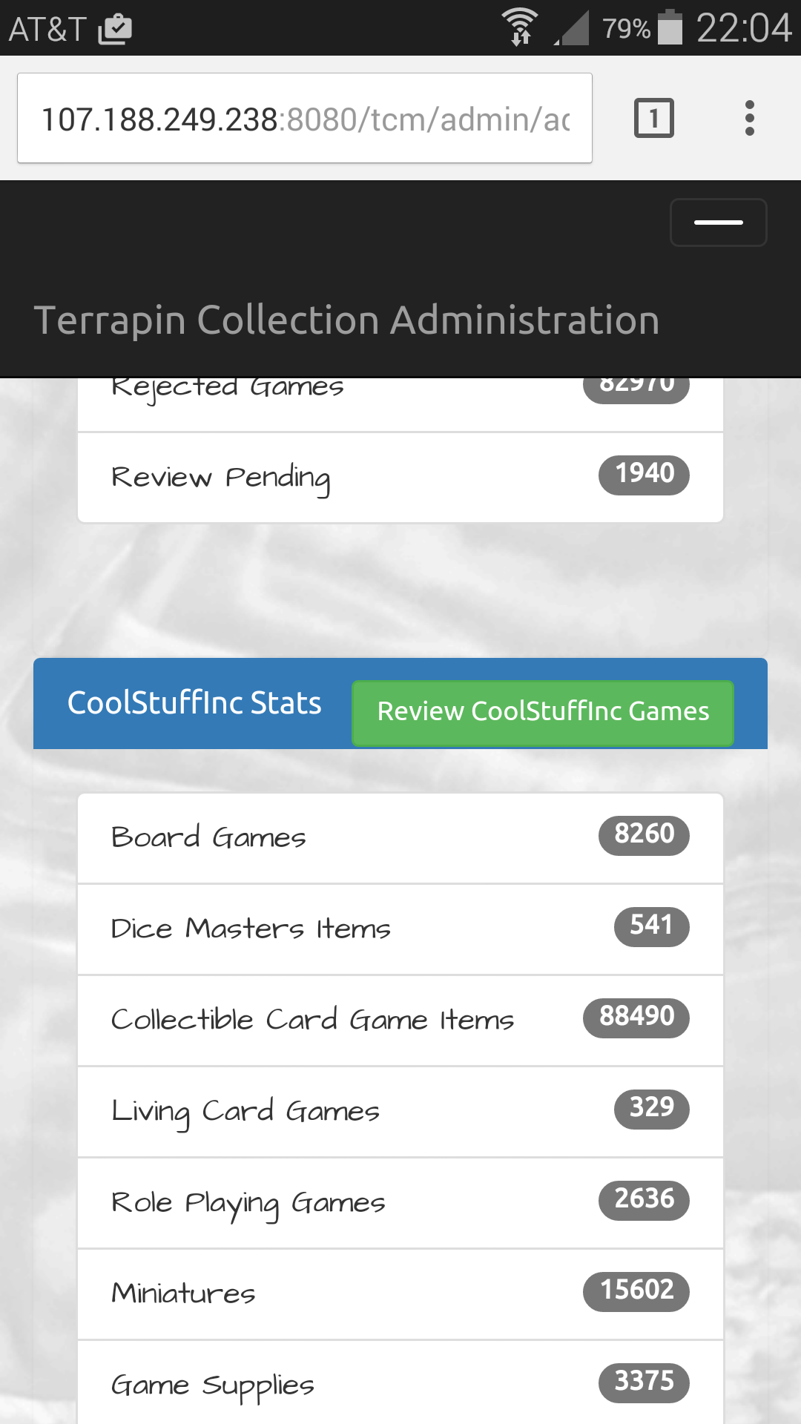 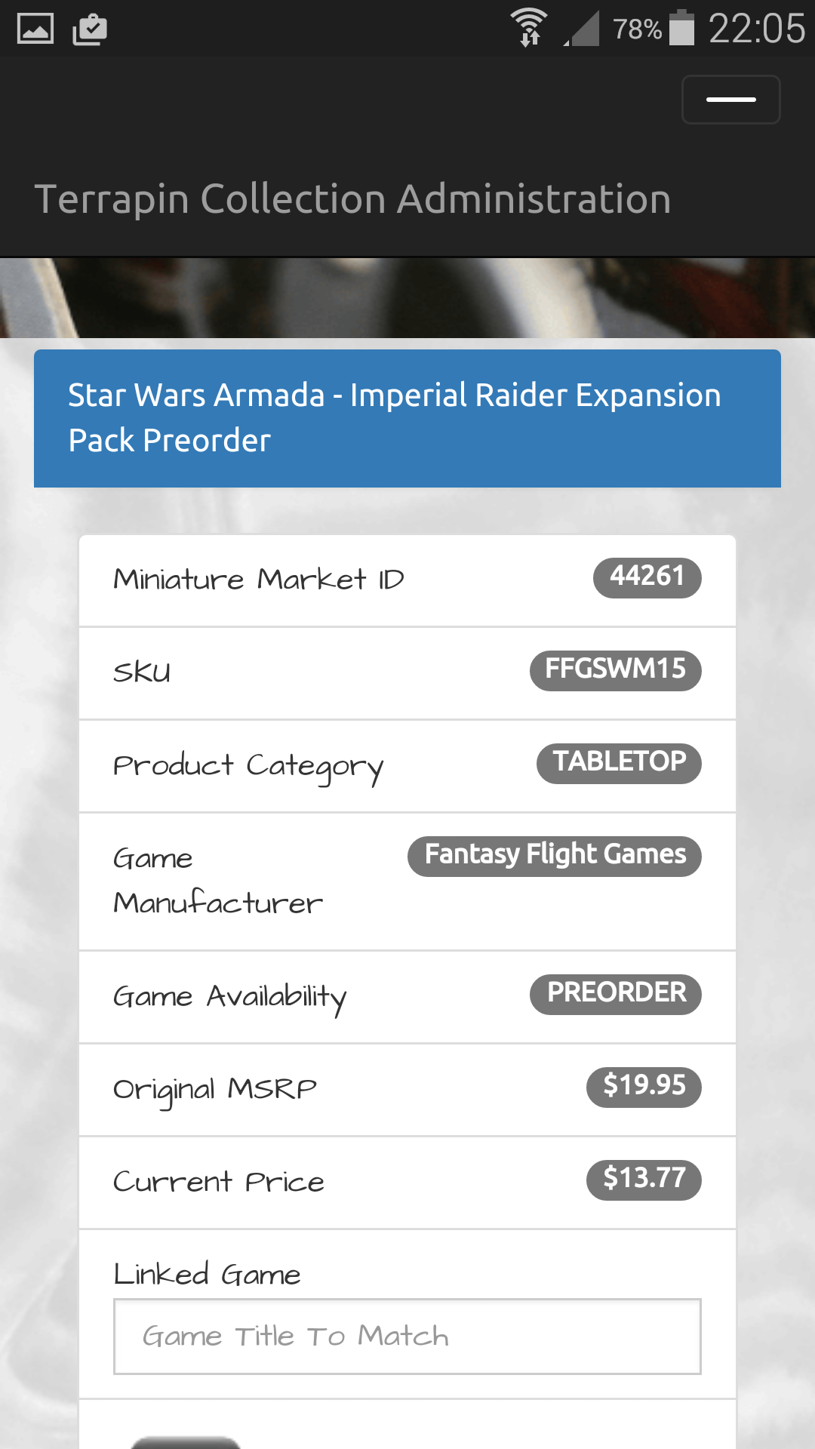 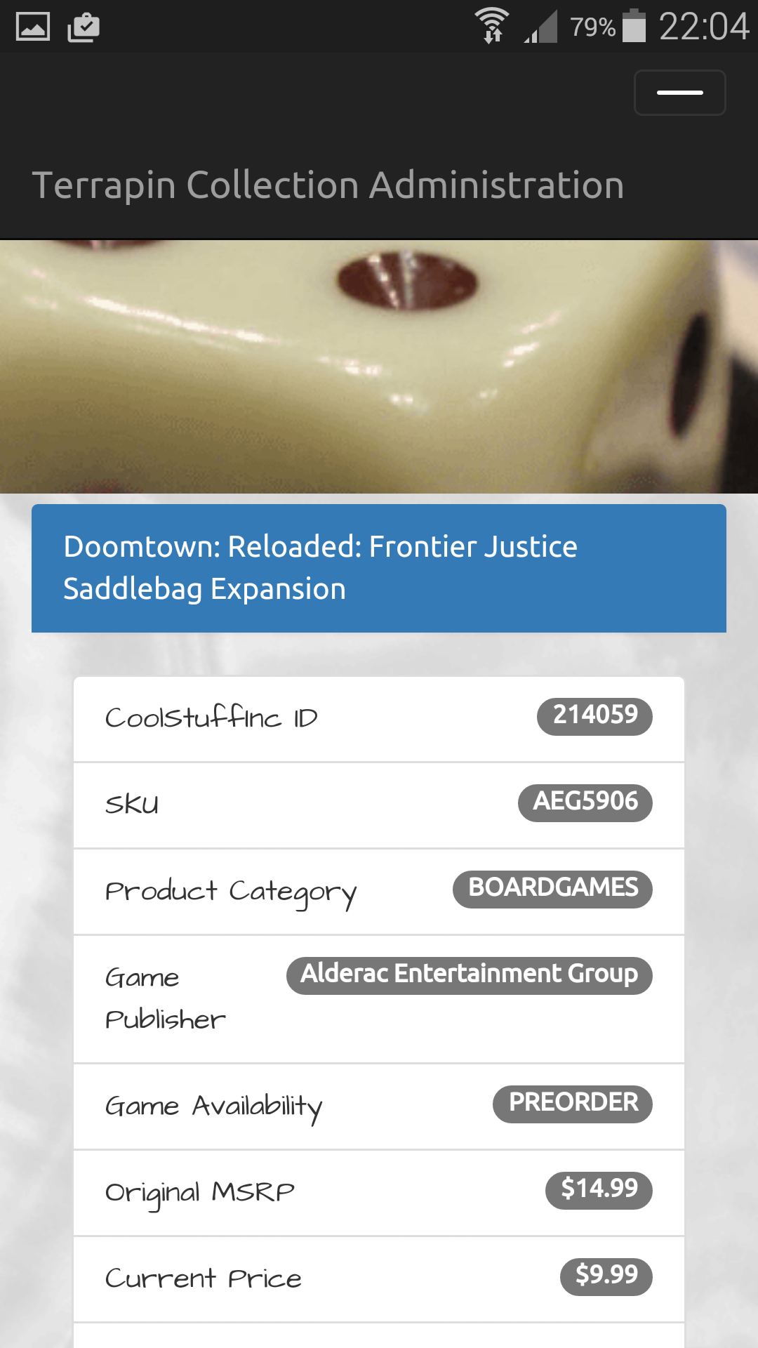

As the screen shots show, the layout is responsive, and the desired elements are being represented correctly in either traditional rich-client or mobile formats.

Presented below are also the Class Diagrams for each of the sub projects. Because the diagrams are rather large in for several projects, I am including the links here to view the source image, so that should the reader desire, they can view the diagrams in greater detail:

<https://github.com/apshaiTerp/ac-games-pojos/blob/master/src/models/allPojos.png>

<https://github.com/apshaiTerp/ac-games-db/blob/master/src/model/GamesDatabase.png>

<https://github.com/apshaiTerp/ac-games-db-mongo/blob/master/src/model/allMongo.png>

<https://github.com/apshaiTerp/ac-games-restservice-spring/blob/master/src/model/allRest.png>

<https://github.com/apshaiTerp/ac-games-agent/blob/master/src/model/allAgent.png>

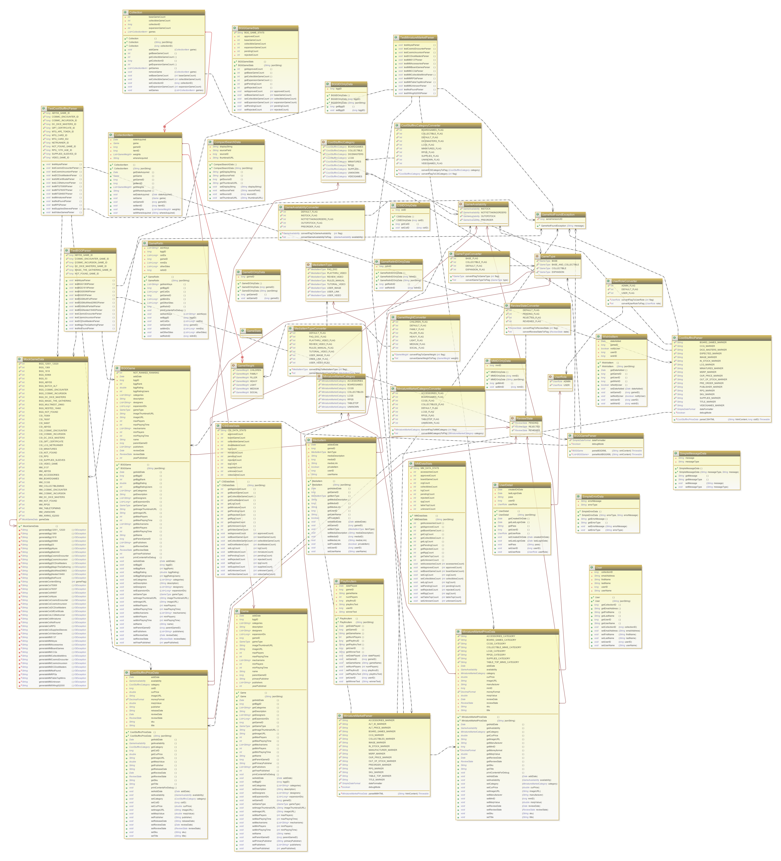

The ac-games-pojos Class Diagram

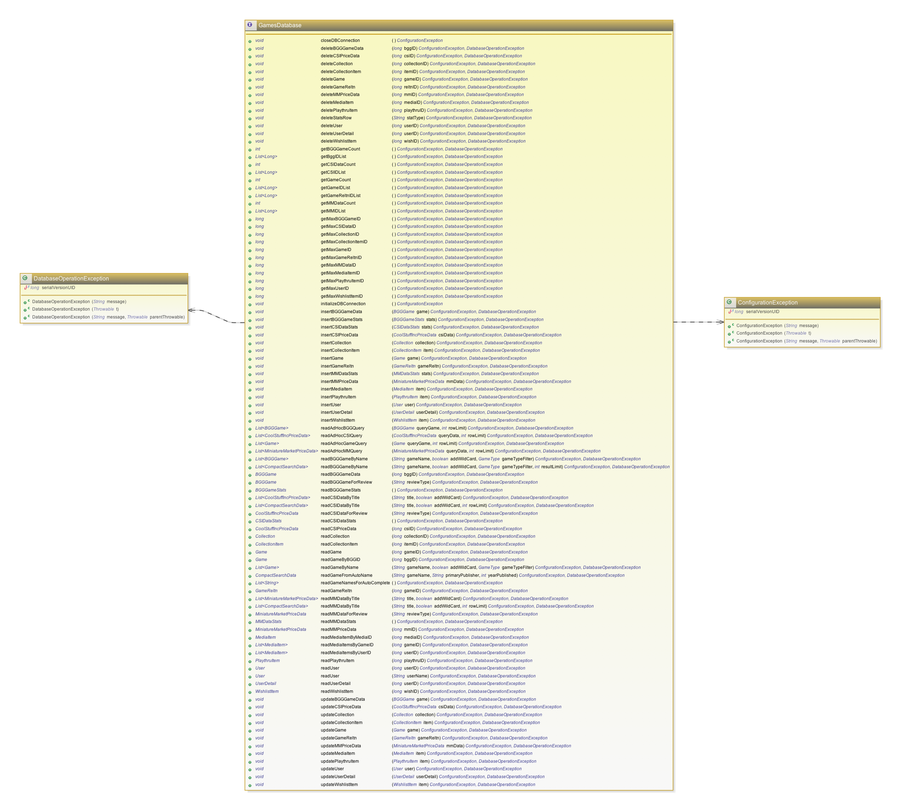

The ac-games-db Class Diagram

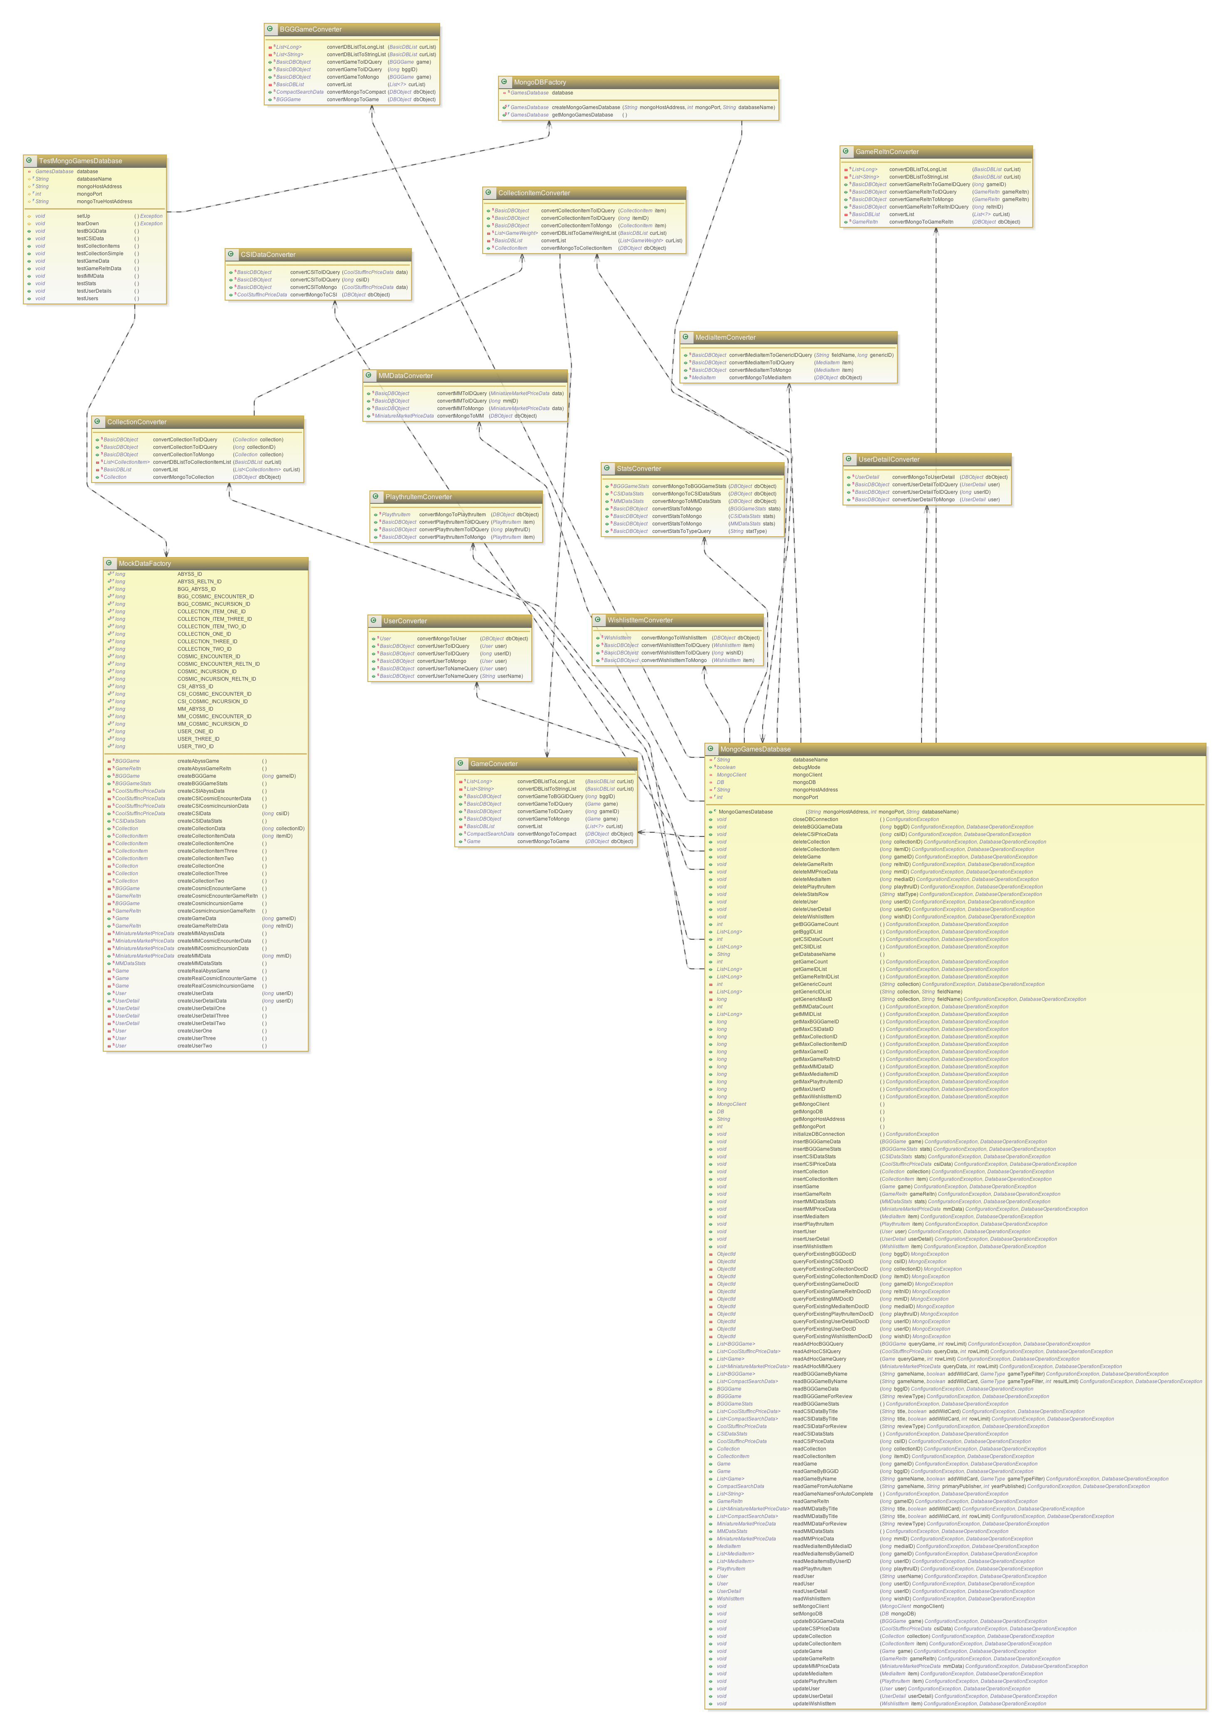

The ac-games-db-mongo Class Diagram

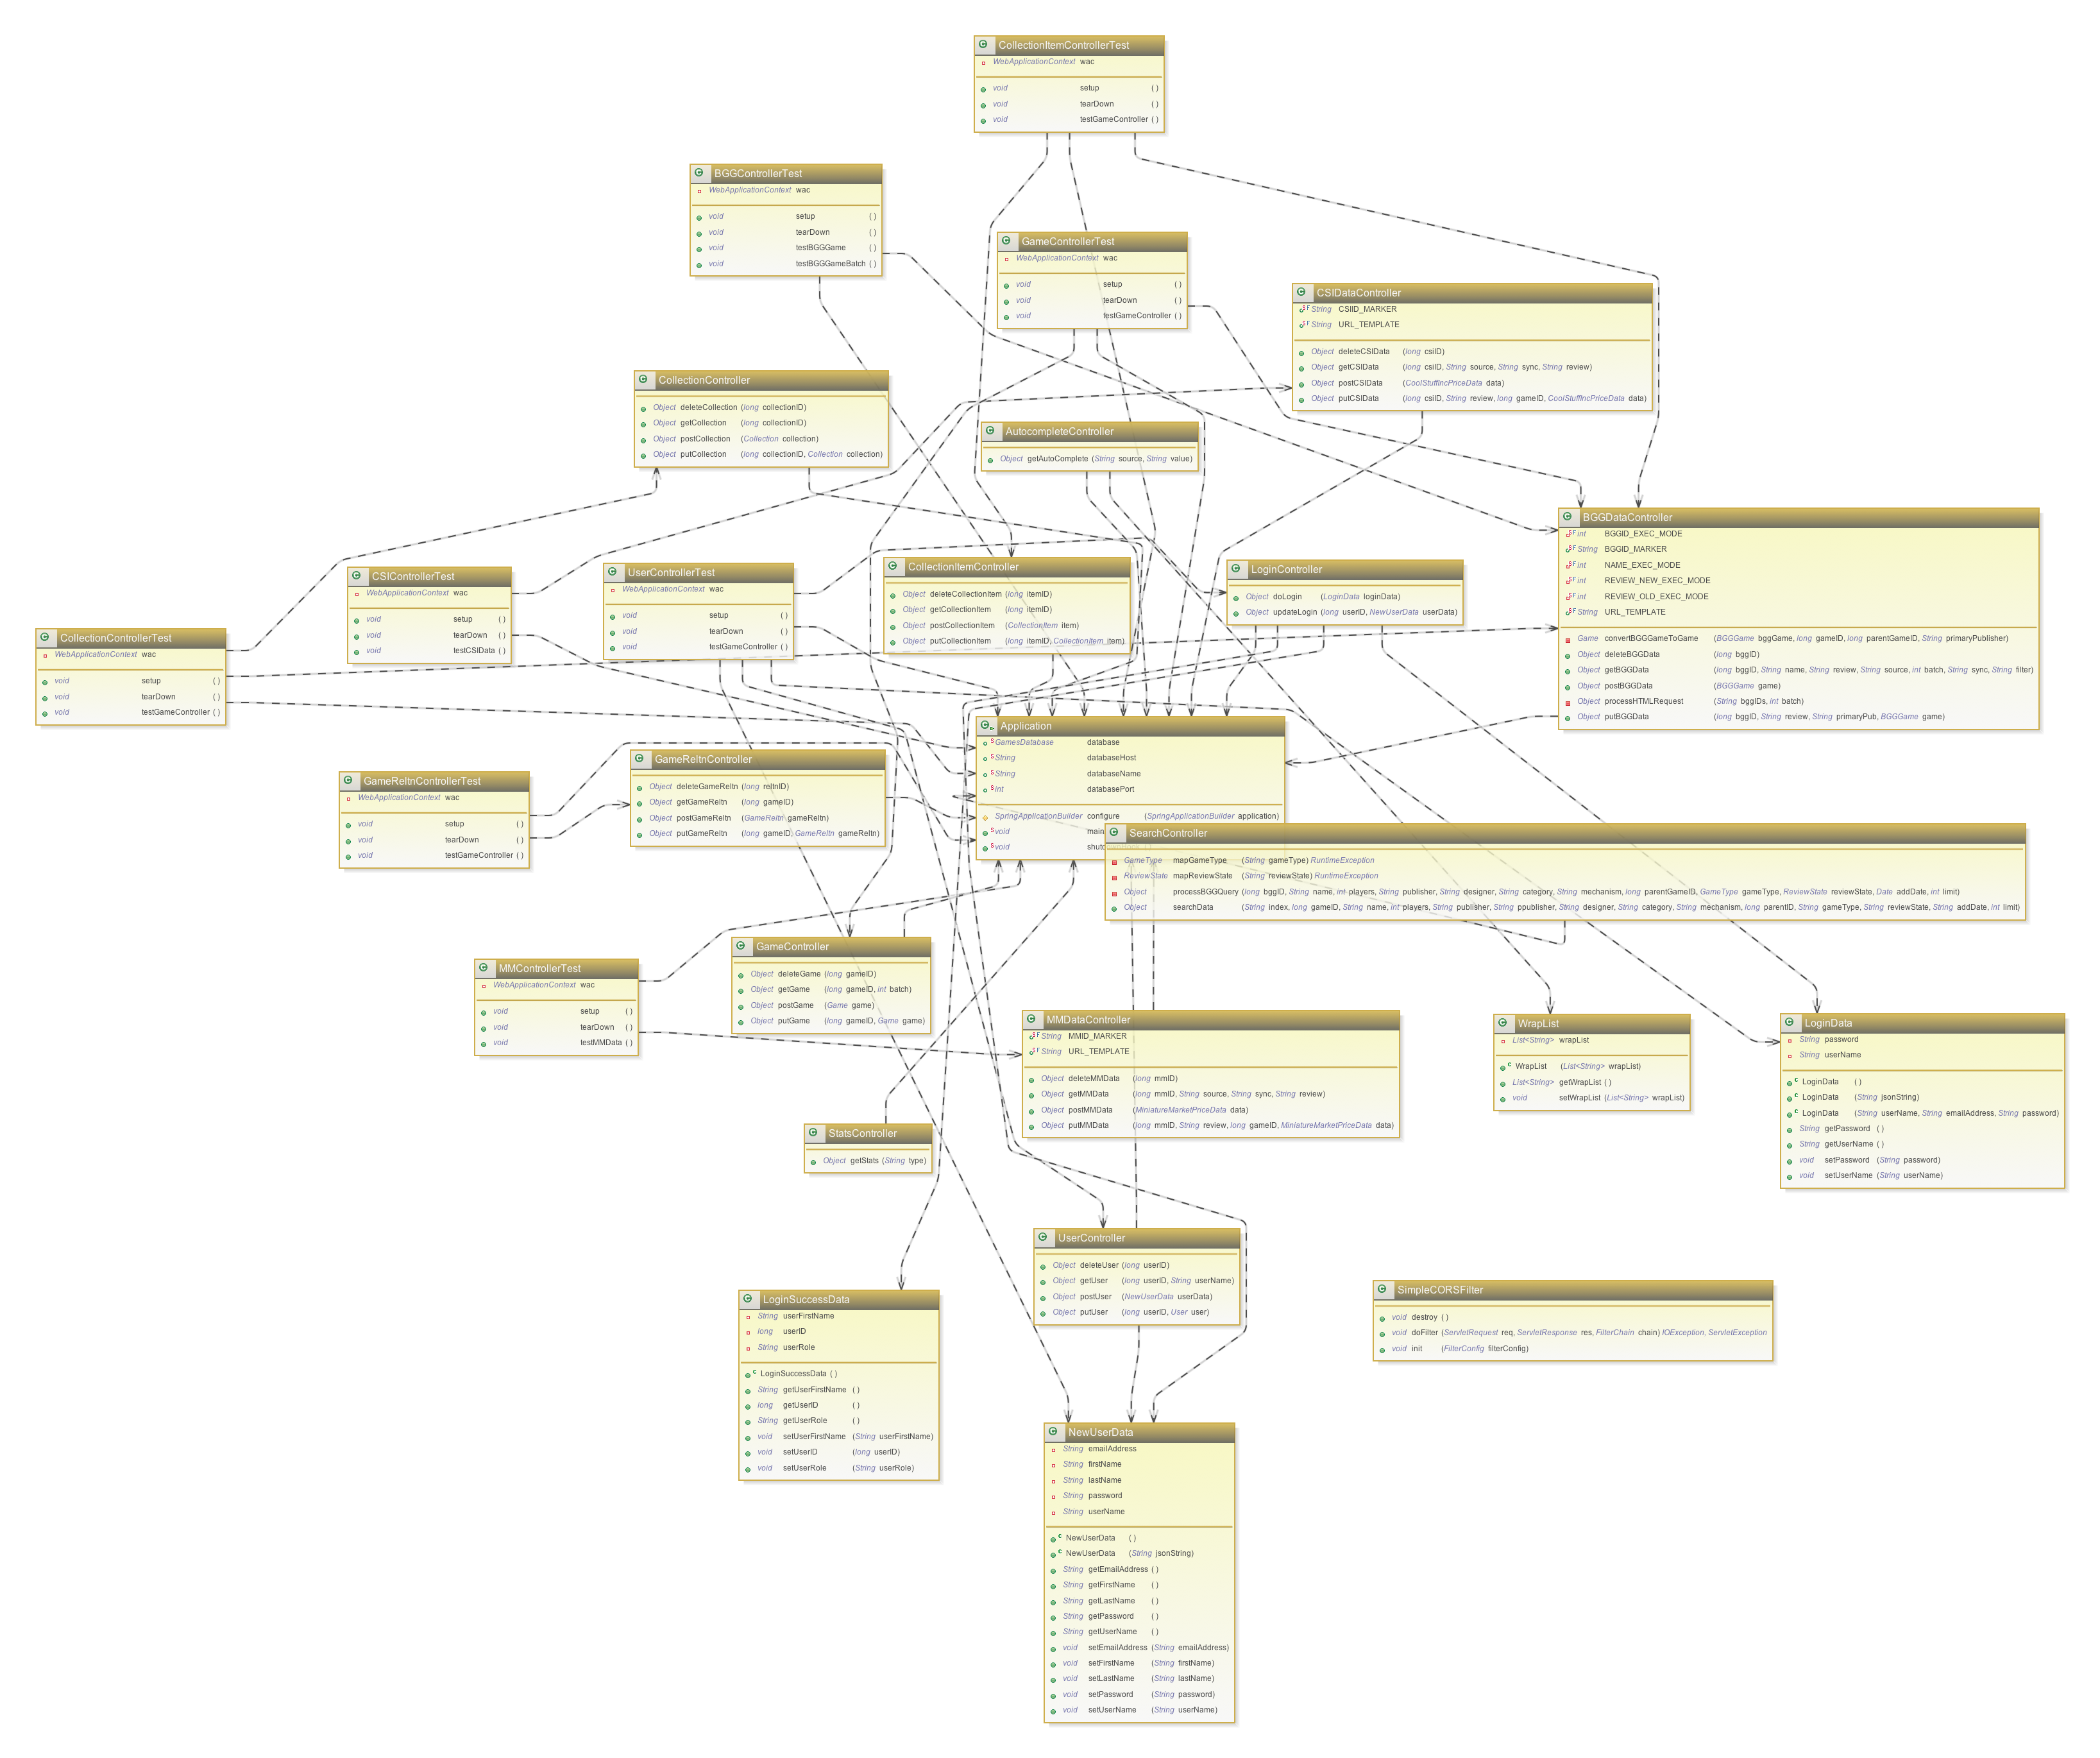

The ac-games-restservice-spring Class Diagram

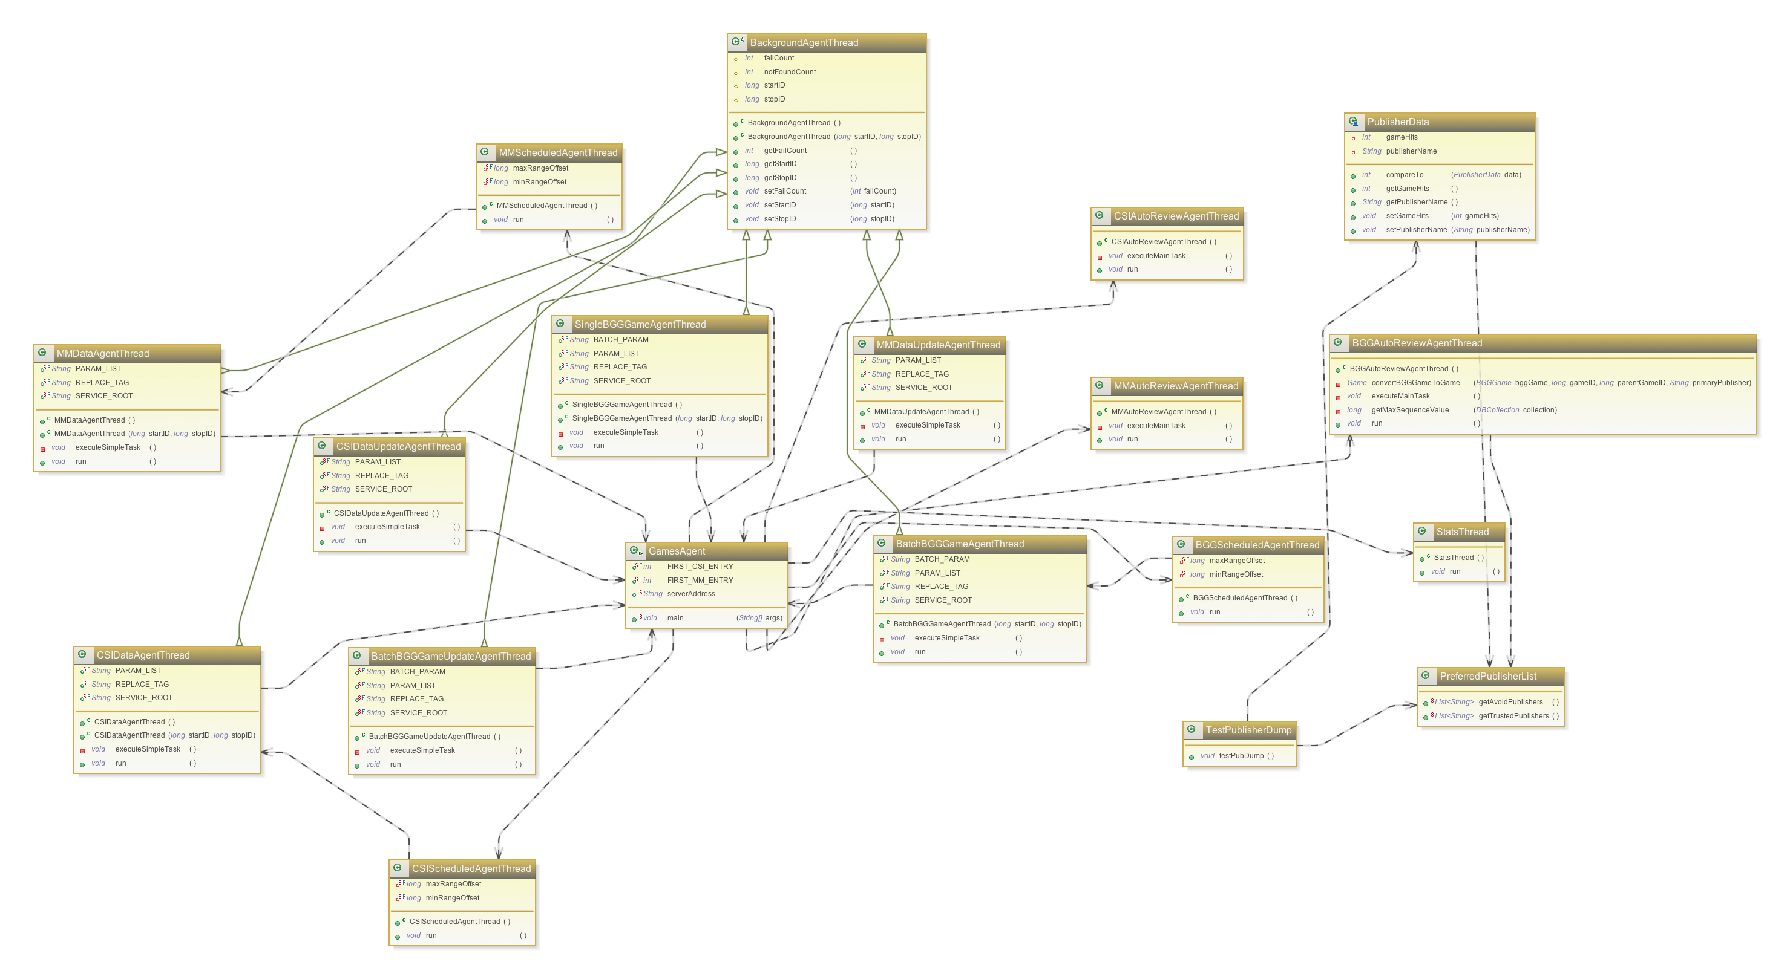

The ac-games-agent Class Diagram

1. **Testing**

Because the majority of the work during this iteration was focused on the front-end, testing was not expanded significantly during this iteration. I consider that to be a strength of the heavy commitment to test development in the previous two iterations.

While all test evidence is documented under the site data, for brevity’s sake I will only be including screen caps from the Surefire plugin report demonstrating the successfully execution of all test sets with this iteration end.

Complete Site Data can be found here:

<https://github.com/apshaiTerp/cs-5551-documentation/blob/master/maven%20sites/ac-games-db/ac-games-pojos-0.3.0-SNAPSHOT%20site/index.html>

<https://github.com/apshaiTerp/cs-5551-documentation/blob/master/maven%20sites/ac-games-db/ac-games-db-0.3.0-SNAPSHOT%20site/index.html>

<https://github.com/apshaiTerp/cs-5551-documentation/blob/master/maven%20sites/ac-games-db/ac-games-db-mongo-0.3.0-SNAPSHOT%20site/index.html>

<https://github.com/apshaiTerp/cs-5551-documentation/blob/master/maven%20sites/ac-games-db/ac-games-restservice-spring-0.3.0-SNAPSHOT%20site/index.html>

<https://github.com/apshaiTerp/cs-5551-documentation/blob/master/maven%20sites/ac-games-db/ac-games-agent-0.3.0-SNAPSHOT%20site/index.html>

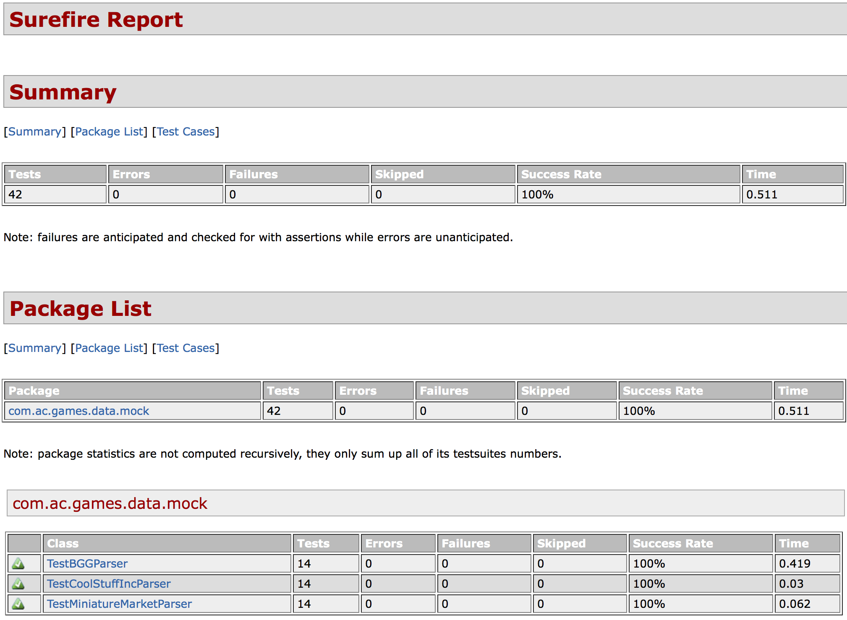

The ac-game-pojos Surefire Test Report

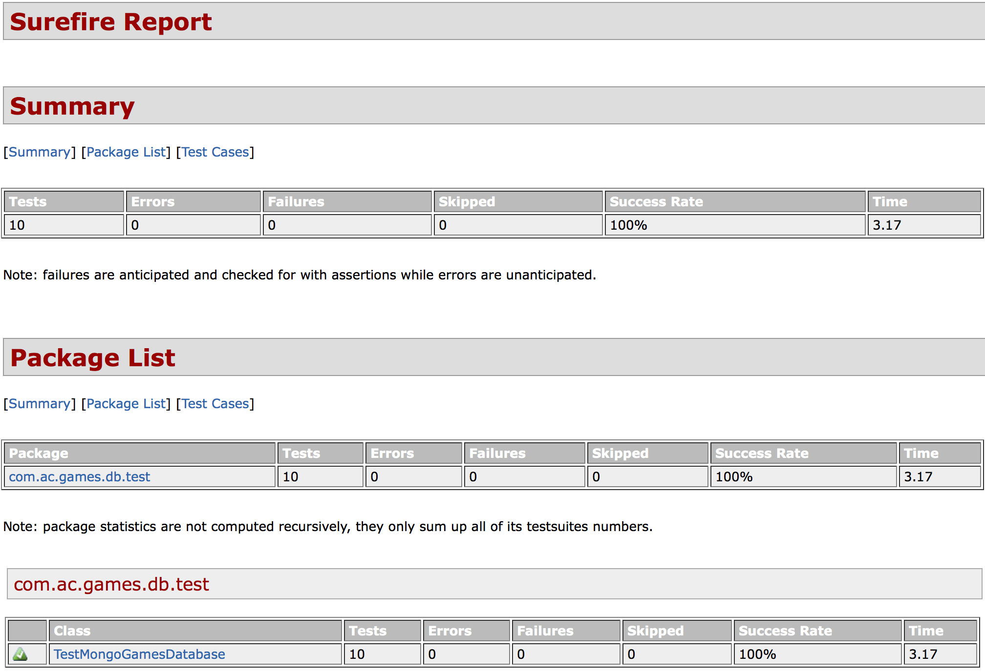

The ac-games-db-mongo Surefire Test Report

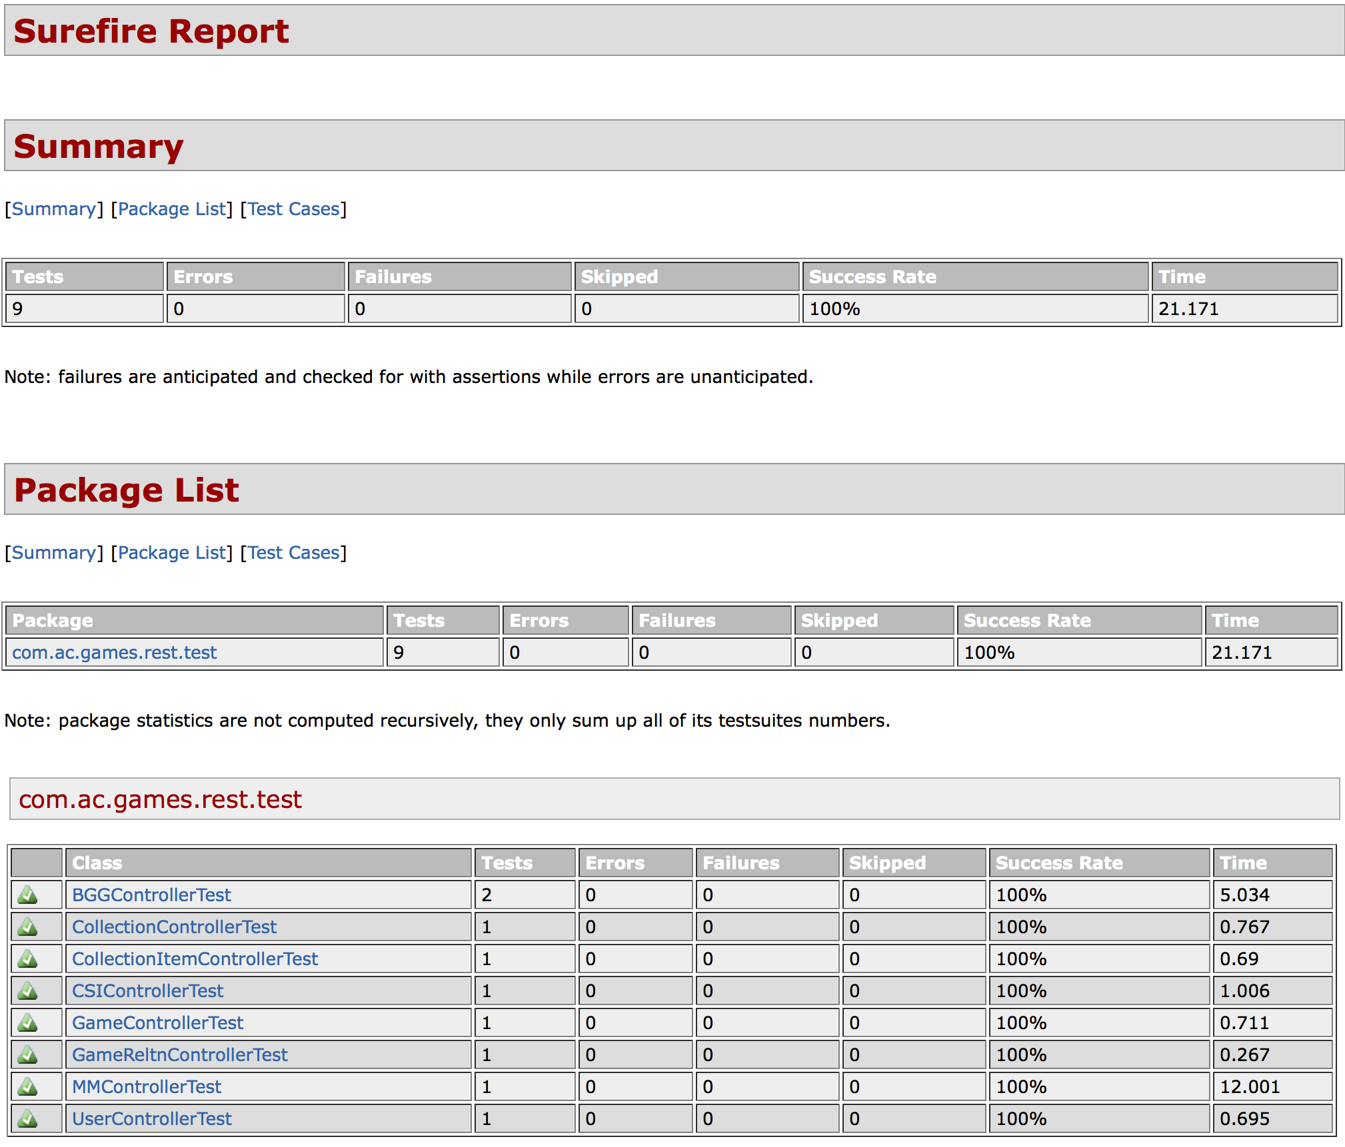

The ac-games-restservice-spring Surefire Test Report

For performance testing, I decided to use Google’s Load Time Analyzer to see how performance for my pages was evaluated. The feedback from these results is not yet incorporated into the site yet, but will be considered for future changes. I also had a hard time running performance tests against most of the Admin pages because I put them behind a session-specific login requirement. This made it impossible to submit requests to analyze those pages to anonymous testing tools since the default behavior when not logged in is to reroute to the login page. The general finding of my testing is that there are some changes that can be made to improve the Mobile experience, but the Interactive elements all passes successfully.

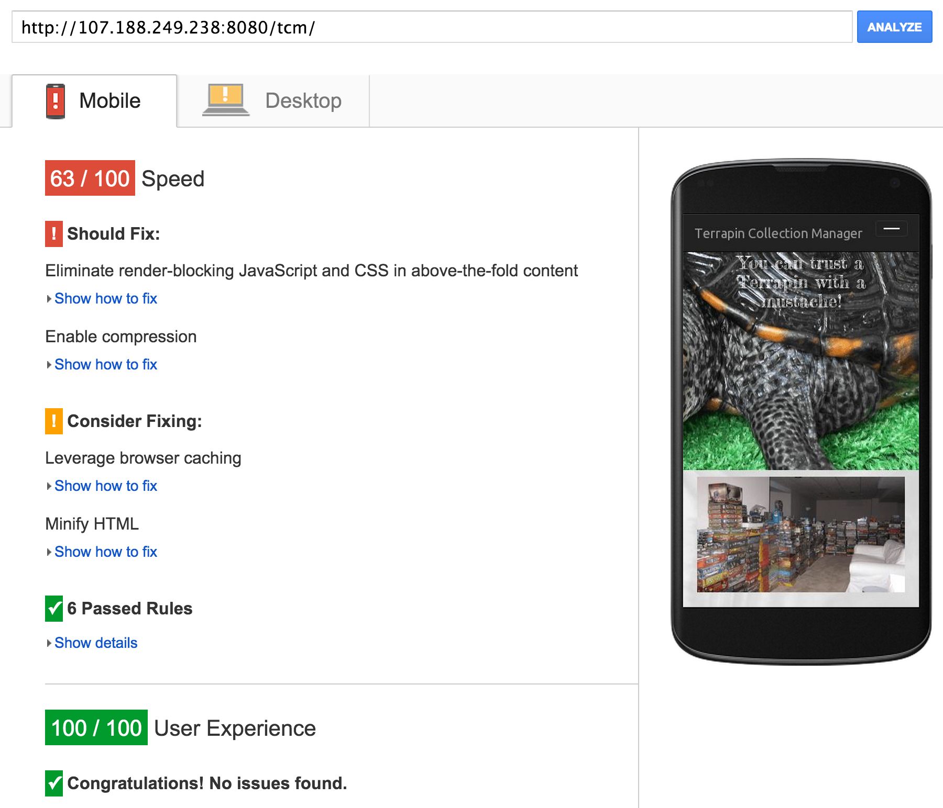

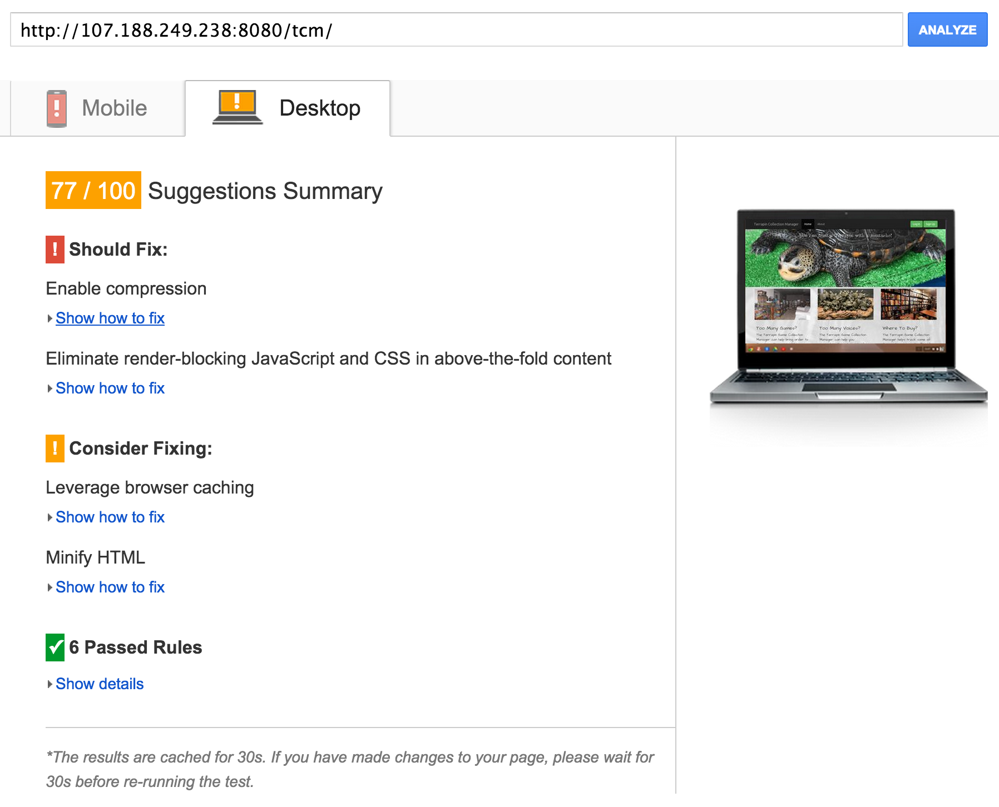

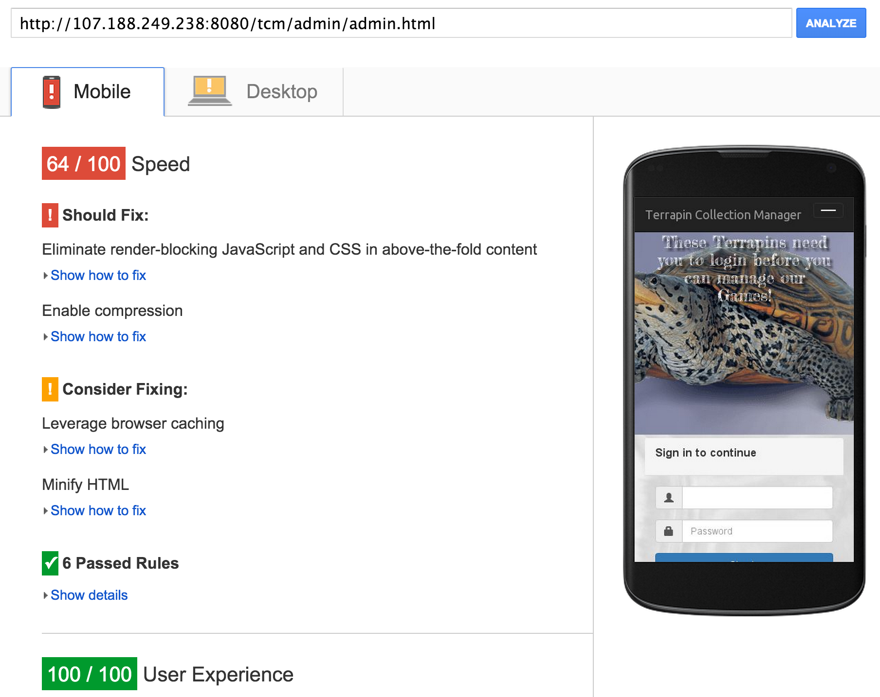

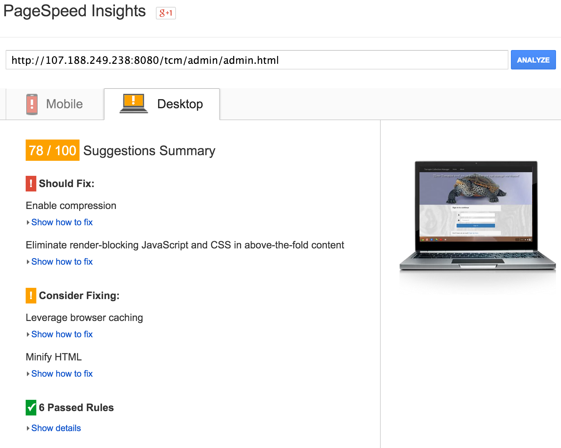

I was also able to test with the YSlow analyzer, which did allow me a little more leverage to run tests behind the login wall. I have included some of those results here as well. Overall, all of my sites earned a B (with an average score of 85) from this site for performance and best practices adoption.



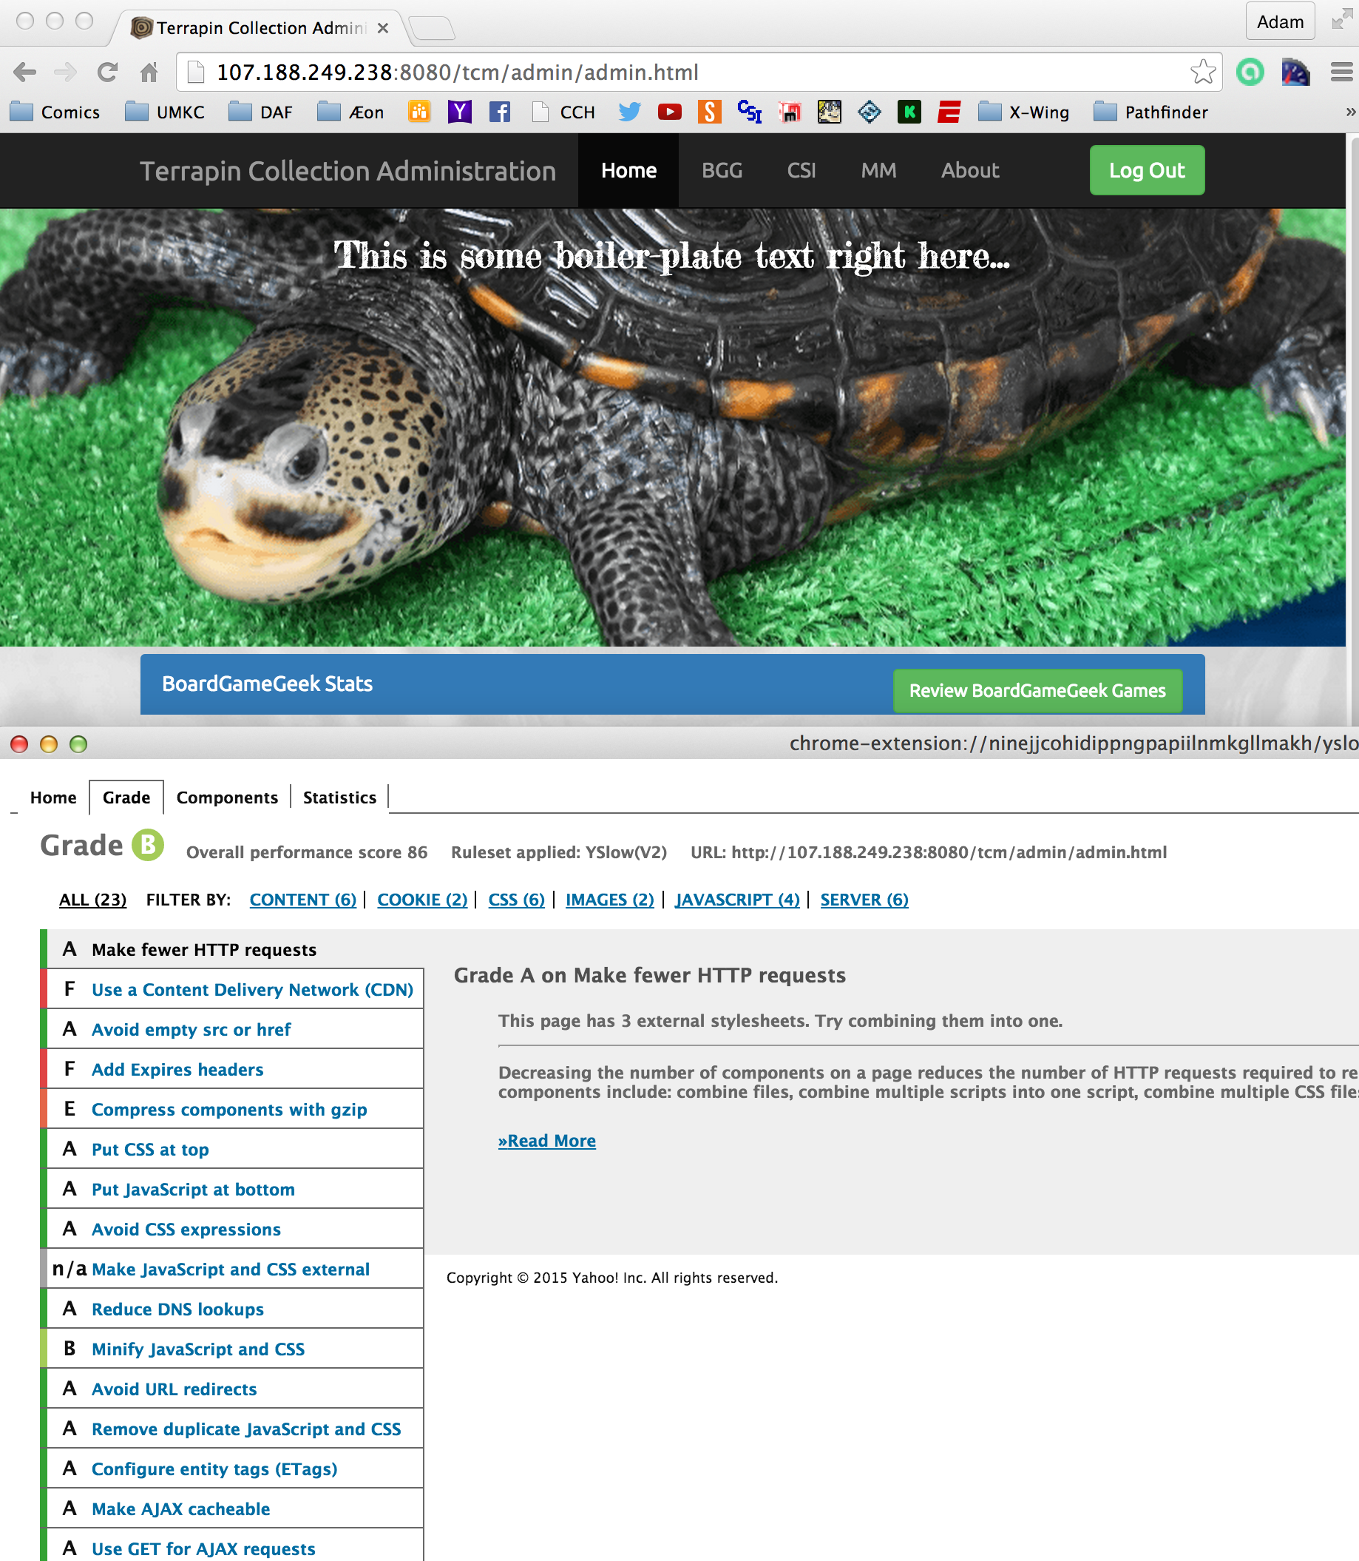

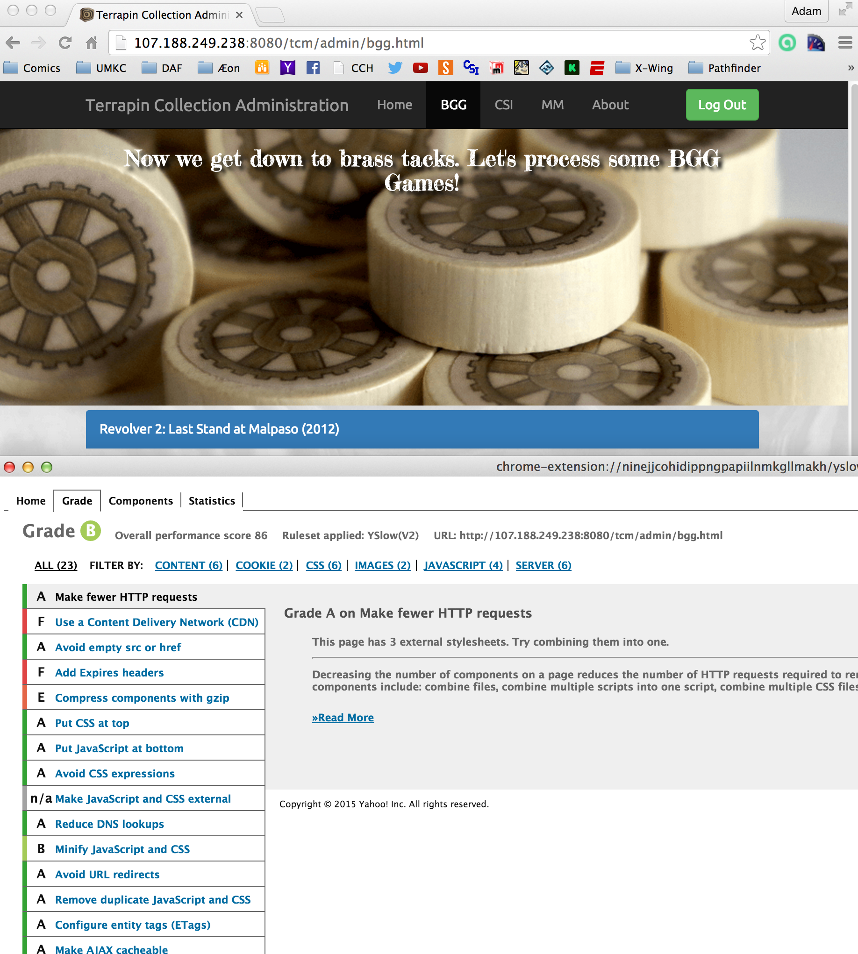

1. **Deployment**

The ScrumDo link to this iteration can be found here:

<https://www.scrumdo.com/projects/project/terrapin-collection-manager/iteration/121583>

The final end-states for my projects has been included in the GitHub documentation site, but this is the list of the final java project end-states:

**ac-games-pojos-0.3.0-SNAPSHOT.jar**

**ac-games-db-0.3.0-SNAPSHOT.jar**

**ac-games-db-mongo-0.3.0-SNAPSHOT.jar**

**ac-games-restservice-spring-0.3.0-SNAPSHOT.jar**

**ac-games-agent-0.3.0-SNAPSHOT.jar**

The root URL for my service is <http://107.188.249.238:8080/ac-games-restservice-spring-0.3.0-SNAPSHOT/>.

The URL for my site is <http://107.188.249.238:8080/tcm/>.

All screen caps for the website generated above were taken using the live site deployment.

1. **Project Management**

Because I am a team of one, I can attest that all work completed on this project is my own. I have not made an effort to track the time spent on this project during this iteration, largely because of the issue discussed above between vacation and illness, but I feel that in spite of those issues, I have managed to accomplish a lot this iteration.

Total story completion on this project may not be possible at this point. I believe at the end of next iteration, I will have a functional site, but some of the polish may still be lacking. I anticipate progress moving quickly on UI developments for the next iteration in part due to the experience gained during this past iteration, both with using external APIs like Bootstrap and jQuery as well as becoming more comfortable with HTML/JavaScript event interaction.

1. **References**

[1] – <https://github.com/apshaiTerp/cs-5551-documentation/blob/master/CS551-Project-Proposal.pdf>

[2] – <https://github.com/apshaiTerp/cs-5551-documentation/blob/master/CS%205551%20Project%20Plan.pdf>